**Activity1:**

**Code:**

/*

Name: Abdullah Mehdi

Regstration No: SP21-BCS-OO2

Activity 1: Showing outputs of x and y

*/

public class Activity1{

public static void main(String[] args) {

double x = 75.3987;

double y = 982.89764;

System.out.printf("%.2f %n", x);

System.out.printf("%.2f %n", y);

System.out.printf("%.3f %n", x);

System.out.printf("%.3f %n", x);

}

}

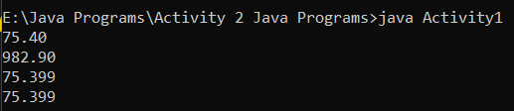**Output:**

**Activity2:**

**Code:**

/*

Name: Abdullah Mehdi

Regstration No: SP21-BCS-OO2

Activity 2: Fixing and Showing the outputs of the statements

*/

public class Activity2{

public static void main(String[] args) {

System.out.printf("amount is %f %e\n", 32.32, 32.32);

System.out.printf("amount is %f %e\n", 32.327, 32.32);

System.out.printf("%5b\n", (1 > 2));

System.out.printf("%4s\n", "Java");

System.out.printf("%-6b%s\n",(1 > 2), "Java");

System.out.printf("%-6b%-5s\n",(1 > 2), "Java");

}

}

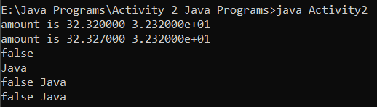**Output:**

**Activity3:**

**Code:**

/*

Name: Abdullah Mehdi

Regstration No: SP21-BCS-OO2

Activity 3: Fixing and Showing the outputs of the statements

*/

public class Activity3{

public static void main(String[] args) {

// System.out.printf("%5d %d", 1, 2, 3); (Here three variables are given while the formatting is of only 2)

// System.out.printf("%5d %f", 1); (Here only one variable is given while the formatting is of 2! Also the number is integer not float)

// System.out.printf("%5d %f", 1, 2); (This one works prefectly fine! Also the numbers are integer not float)

System.out.printf("%-1d %d %d\n", 1, 2, 3);

System.out.printf("%-1d\n", 1);

System.out.printf("%-1d %d\n", 1, 2);

}

}

**Output:**

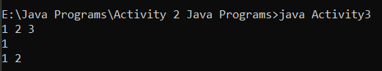

**Activity4:**

**Code:**

/*

Name: Abdullah Mehdi

Regstration No: SP21-BCS-OO2

Activity 2: Fixing and Showing the outputs of degrees and radians

*/

public class Activity4{

public static void main(String[] args) {

String s1 = "Degrees";

String s2 = "Radians";

String s3 = "Sine";

String s4 = "Cosine";

String s5 = "Tangent";

// Display the header of the table using System.out.printf()

int degrees = 30;

double radians = Math.toRadians(degrees);

double sin = Math.sin(radians);

double cos = Math.cos(radians);

double tan = Math.tan(radians);

// Display the Data of the table using System.out.printf()

System.out.printf("%-1s %-1s %-1s %9s %8s\n", s1, s2, s3, s4, s5);

System.out.printf("%-7d %-7.4f %-7.4f %-7.4f %-7.4f\n", degrees, radians, sin, cos, tan);

degrees = 60;

radians = Math.toRadians(degrees);

sin = Math.sin(radians);

cos = Math.cos(radians);

tan = Math.tan(radians);

// Display the Data of the table using System.out.printf()

System.out.printf("%-7d %-7.4f %-7.4f %-7.4f %-7.4f\n", degrees, radians, sin, cos, tan);

}

}

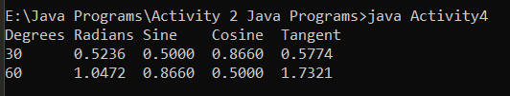Output:

**Activity 5**

**Code:**

/*

Name: Abdullah Mehdi

Regstration No: SP21-BCS-OO2

Activity 5: Fixing and Showing the outputs of x, y and z

*/

public class Activity5{

public static void main(String[] args) {

int x = 10;

int y = 15;

int z = 20;

System.out.println(!(x > 10));

System.out.println(x <= 5 || y < 15);

System.out.println((x != 5 ) && (y != z));

System.out.println(x >= z || (x + y >= z));

System.out.println((x <= y - 2) && (y >= z) || (z - 2 != 20));

}

}

Output:

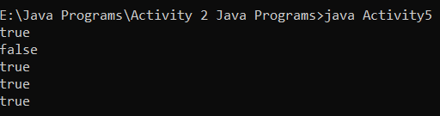

**Activity 6**

**Code:**

/*

Name: Abdullah Mehdi

Regstration No: SP21-BCS-OO2

Activity 6: Fixing and Showing the outputs of x, y and z (part2)

*/

public class Activity6{

public static void main(String[] args) {

int x = 3;

int y = 4;

int z = 7;

int w = 1;

System.out.println("x == y: " + (x == y ));

System.out.println("x != z: " + (x != z ));

System.out.println("y == z – 3: " + (y == z - 3));

System.out.println("!(z > w): " + ! (z > w));

System.out.println("x + y < z: " + (x + y < z));

}

}

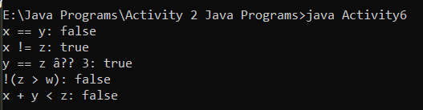Output:

**Activity 7**

**Code:**

/*

Name: Abdullah Mehdi

Regstration No: SP21-BCS-OO2

Activity 2: Fixing and Showing the outputs of x, y and z (part2)

*/

public class Activity7{

public static void main(String[] args) {

boolean b1 = true;

boolean b2 = false;

boolean b3 = (b1 == b2);

System.out.print("The value of b3 is: " + b3);

}

}

Output:



**Activity 8**

**Code:**

/*

Name: Abdullah Mehdi

Regstration No: SP21-BCS-OO2

Activity 8: if-else statement

*/

import java.util.Scanner;

public class Activity8{

public static void main(String[] args) {

Scanner input = new Scanner(System.in);

System.out.println("Enter a number");

int x = input.nextInt();

System.out.println("Enter another number");

int y = input.nextInt();

if(x > y){

System.out.println("y is smaller than x: " + y );

}

else if(x < y){

System.out.println("x is smaller than y: " + x );

}

}

}

Output:

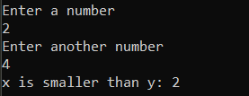

**Activity 9**

**Code:**

/*

Name: Abdullah Mehdi

Regstration No: SP21-BCS-OO2

Activity 9: checking the number is positive, negative or zero

*/

import java.util.Scanner;

public class Activity9{

public static void main(String[] args) {

Scanner input = new Scanner(System.in);

System.out.print("Enter a number: ");

int x = input.nextInt();

if(x > 0){

System.out.println("The number is positive: " + x );

}

else if(x < 0){

System.out.println("The number is negative: " + x );

}

else if(x == 0){

System.out.println("The number is equal to zero: " + x );

}

}

}

Output:

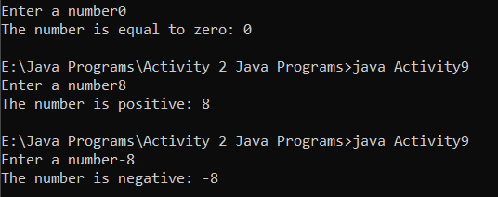

**Activity 10**

**Code:**

/*

Name: Abdullah Mehdi

Regstration No: SP21-BCS-OO2

Activity 10: printing the smallest numeber

*/

import java.util.Scanner;

public class Activity10{

public static void main(String[] args) {

Scanner input = new Scanner(System.in);

System.out.print("Enter a number x: ");

int x = input.nextInt();

System.out.print("Enter a number y: ");

int y = input.nextInt();

System.out.print("Enter a number z: ");

int z = input.nextInt();

if(x < y && x < z){

System.out.println("X is the smallest number: " + x );

}

else if(y < x && y < z){

System.out.println("Y is the smallest number: " + y );

}

else if(z < x && z < y){

System.out.println("Z is the smallest number: " + z );

}

}

}

**Output:**

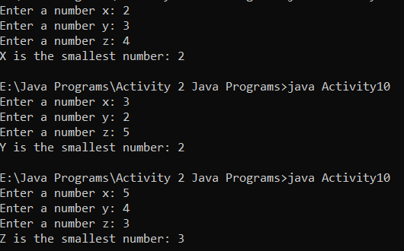

**Activity 11**

**Code:**

/*

Name: Abdullah Mehdi

Regstration No: SP21-BCS-OO2

Activity 11: Checking the equality of numbers

*/

import java.util.Scanner;

public class Activity11{

public static void main(String[] args) {

Scanner input = new Scanner(System.in);

System.out.print("Enter an integer x: ");

int x = input.nextInt();

System.out.print("Enter an integer y: ");

int y = input.nextInt();

System.out.print("Enter an integer z: ");

int z = input.nextInt();

if(x == y && x == z && y == x && y == z && z == x && z == y){

System.out.println("All the integers are equal to each other: 3");

}

else if(x == y && x != z || x != y && x == z && y == x && y != z || y != x && y == z && z == x && z != y || z != x && z == y){

System.out.println("Two integers are equal to each other: 2");

}

else if(x != y && x != z && y != x && y != z && z != x && z != y){

System.out.println("None of them are equal to each other: 0" );

}

}

}

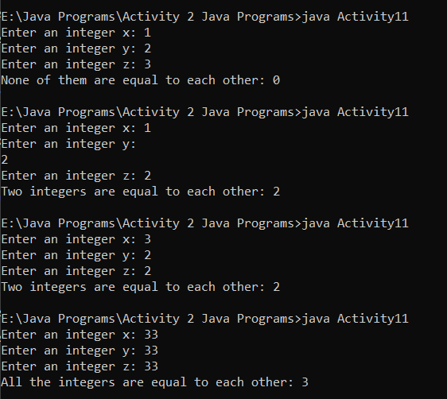**Output:**

**Activity 12**

**Code:**

/*

Name: Abdullah Mehdi

Regstration No: SP21-BCS-OO2

Activity 12: Roman Numerials

*/

import java.util.Scanner;

public class Activity12{

public static void main(String[] args) {

Scanner input = new Scanner(System.in);

System.out.print("Enter a number: ");

int x = input.nextInt();

if(x == 1){

System.out.println("Roman Numerial: I");

}

else if(x == 2){

System.out.println("Roman Numerial: II");

}

else if(x == 3){

System.out.println("Roman Numerial: III");

}

else if(x == 4){

System.out.println("Roman Numerial: IV");

}

else if(x == 5){

System.out.println("Roman Numerial: V");

}

else if(x == 6){

System.out.println("Roman Numerial: VI");

}

else if(x == 7){

System.out.println("Roman Numerial: VII");

}

else if(x == 8){

System.out.println("Roman Numerial: VIII");

}

else if(x == 9){

System.out.println("Roman Numerial: IX");

}

else if(x == 10){

System.out.println("Roman Numerial: X");

}

}

}

**Output:**

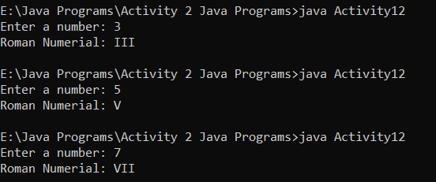

**Activity 13**

**Code:**

/*

Name: Abdullah Mehdi

Regstration No: SP21-BCS-OO2

Activity 13: Area calculation

*/

import java.util.Scanner;

public class Activity13{

public static void main(String[] args) {

Scanner input = new Scanner(System.in);

System.out.print("Enter the length of rectangle 1: ");

int length1 = input.nextInt();

System.out.print("Enter the width of rectangle 1: ");

int width1 = input.nextInt();

int area = length1 * width1;

System.out.print("Enter the length of rectangle 2: ");

int length2 = input.nextInt();

System.out.print("Enter the width of rectangle 2: ");

int width2 = input.nextInt();

int area2 = length2 * width2;

if(area == area2){

System.out.println("Both rectagnles have same area");

}

else if(area > area2){

System.out.println("Rectangle 1 has more area than rectangle 2");

}

else if(area < area2){

System.out.println("Rectangle 2 has more area than rectangle 1");

}

}

}

**Output:**

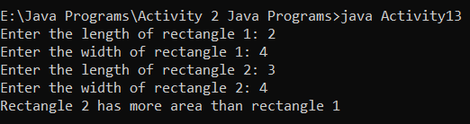

**Activity 14**

**Code:**

/*

Name: Abdullah Mehdi

Regstration No: SP21-BCS-OO2

Activity 14: weight calculation

*/

import java.util.Scanner;

public class Activity14{

public static void main(String[] args) {

Scanner input = new Scanner(System.in);

System.out.print("Enter object's mass in kilograms: ");

int mass = input.nextInt();

double weight = mass * 9.8;

if(weight > 1000){

System.out.println("The object is way too heavy");

}

else if(weight < 10){

System.out.println("The object is way too light");

}

}

}

**Output:**

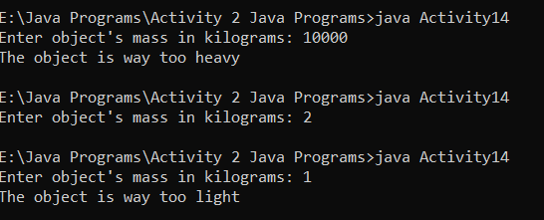

**Activity 15**

**Code:**

/*

Name: Abdullah Mehdi

Regstration No: SP21-BCS-OO2

Activity 15: Magic dates

*/

import java.util.Scanner;

public class Activity15{

public static void main(String[] args) {

Scanner input = new Scanner(System.in);

System.out.print("Enter the month (In numbers): ");

int month = input.nextInt();

System.out.print("Enter the date: ");

int date = input.nextInt();

System.out.print("Enter the year: ");

int year = input.nextInt();

int lastDigitsYear = year % 100;

if(month * date == lastDigitsYear){

System.out.println("The date is magical: " + month + "/" + date + "/" + lastDigitsYear);

}

else {

System.out.println("The date is not magical");

}

}

}

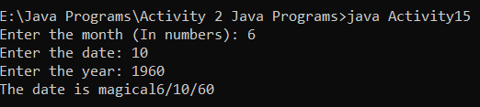**Output:**

**Activity 16**

**Code:**

/*

Name: Abdullah Mehdi

Regstration No: SP21-BCS-OO2

Activity 16: Color Mixing

*/

import java.util.Scanner;

public class Activity16{

public static void main(String[] args) {

Scanner input = new Scanner(System.in);

System.out.print("Enter any primary color (1: red, 2: blue and 3: yellow): ");

int color1 = input.nextInt();

System.out.print("Enter another primary color (1: red, 2: blue and 3: yellow): ");

int color2 = input.nextInt();

if(color1 != 1 && color1 != 2 && color1 != 3){

System.out.println("You didn't enter the primary colors");

}

else if(color2 != 1 && color2 != 2 && color2 != 3){

System.out.println("You didn't enter the primary colors");

}

if(color1 == 1 && color2 == 2){

System.out.println("You get purple");

}

else if(color1 == 1 && color2 == 3){

System.out.println("You get orange");

}

else if(color1 == 2 && color2 == 3){

System.out.println("You get Green");

}

}

}

**Output:**

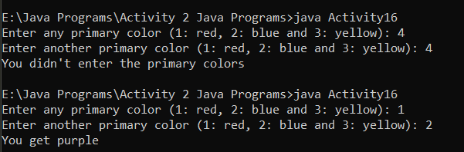

**Activity 17**

**Code:**

/*

Name: Abdullah Mehdi

Regstration No: SP21-BCS-OO2

Activity 17: Dollar Game

*/

import java.util.Scanner;

public class Activity17{

public static void main(String[] args) {

Scanner input = new Scanner(System.in);

System.out.print("Enter number of pennes: ");

double pennes = input.nextDouble();

System.out.print("Enter number of Nickels: ");

double nickels = input.nextDouble();

System.out.print("Enter number of Dimes: ");

double dimes = input.nextDouble();

System.out.print("Enter number of Quaters: ");

double quarters = input.nextDouble();

double totalAmount = (pennes * 0.01) + (nickels * 0.05) + (dimes * 0.10) + (quarters * 0.25);

if(totalAmount == 1){

System.out.println("Congratulations! you won the game");

}

else if(totalAmount > 1){

System.out.println("The total amount is more than a dollar");

}

else{

System.out.print("The total amount is less than a dollar");

}

}

}

**Output:**

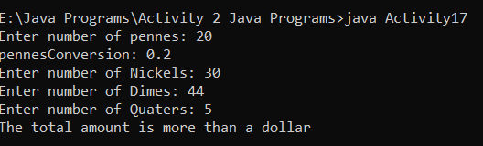

**Activity 18**

**Code:**

/*

Name: Abdullah Mehdi

Regstration No: SP21-BCS-OO2

Activity 18: Books and points

*/

import java.util.Scanner;

public class Activity18{

public static void main(String[] args) {

Scanner input = new Scanner(System.in);

System.out.print("Enter the number of books you purchased last month: ");

int books = input.nextInt();

if(books == 0){

System.out.println("You earned 0 points");

}

else if(books == 1){

System.out.println("You earned 5 points");

}

else if(books == 2){

System.out.print("You earned 15 points");

}

else if(books == 3){

System.out.print("You earned 30 points");

}

else if(books == 4){

System.out.print("You earned 60 points");

}

}

}

**Output:**

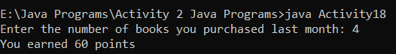

**Activity 19**

**Code:**

/*

Name: Abdullah Mehdi

Regstration No: SP21-BCS-OO2

Activity 19: Discount calculation

*/

import java.util.Scanner;

public class Activity19{

public static void main(String[] args) {

Scanner input = new Scanner(System.in);

System.out.print("Enter the number of packages purchased: ");

int packageAmount = input.nextInt();

int retailPrice = (packageAmount * 99);

if(packageAmount >= 10 && packageAmount <= 19){

System.out.println("You get 20% diccount: " + (retailPrice * 20) / 100 );

}

else if(packageAmount >= 20 && packageAmount <= 49){

System.out.println("You get 30% diccount: " + (retailPrice * 30) / 100 );

}

else if(packageAmount >= 40 && packageAmount <= 99){

System.out.print("You get 40% diccount: " + (retailPrice * 40) / 100);

}

else if(packageAmount >= 100){

System.out.print("You get 50% diccount: " + (retailPrice * 50) / 100);

}

}

}

**Output:**

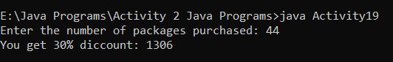

**Activity 20**

**Code:**

/*

Name: Abdullah Mehdi

Regstration No: SP21-BCS-OO2

Activity 20: shipping charging calculation

*/

import java.util.Scanner;

public class Activity20{

public static void main(String[] args) {

Scanner input = new Scanner(System.in);

System.out.print("Enter the weight of packages purchased: ");

int packageWeight = input.nextInt();

if(packageWeight <= 2){

System.out.println("The shipping charges would be: $1.10 ");

}

else if(packageWeight > 2 && packageWeight <= 6){

System.out.println("The shipping charges would be: $2.20 ");

}

else if(packageWeight > 6 && packageWeight <= 10){

System.out.print("The shipping charges would be: $3.70 ");

}

else if(packageWeight > 10){

System.out.print("The shipping charges would be: $3.80 ");

}

}

}

**Output:**

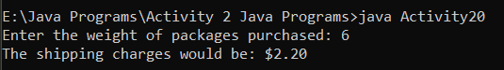

**Activity 21**

**Code:**

/*

Name: Abdullah Mehdi

Regstration No: SP21-BCS-OO2

Activity 21: BMI calculation

*/

import java.util.Scanner;

public class Activity21{

public static void main(String[] args) {

Scanner input = new Scanner(System.in);

System.out.print("Enter the weight of a person in pounds: ");

int weight = input.nextInt();

System.out.print("Enter the height of a person in inches: ");

int height = input.nextInt();

height = height * height;

int bmi = weight * 703 / height;

if(bmi >= 18.5 && bmi <= 25){

System.out.println("Your weight is optimal ");

}

else if(bmi < 18.5){

System.out.println("You're underweight ");

}

else if(bmi > 25){

System.out.println("You're overweight ");

}

}

}

**Output:**

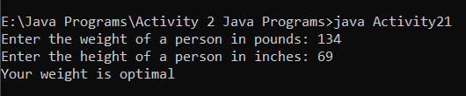

**Activity 22**

**Code:**

/*

Name: Abdullah Mehdi

Regstration No: SP21-BCS-OO2

Activity 22: Time Calculator

*/

import java.util.Scanner;

public class Activity22{

public static void main(String[] args) {

Scanner input = new Scanner(System.in);

System.out.print("Enter the number of seconds: ");

int seconds = input.nextInt();

int minutes = seconds / 60;

int hours = seconds / 3600;

int days = seconds / 86400;

if(seconds >= 60 && seconds < 3600){

System.out.println("The number of minutes are: " + minutes + " minutes.");

}

else if(seconds >= 3600 && seconds < 86400){

System.out.println("The number of hours are : " + hours + " hours.");

}

else if(seconds >= 86400){

System.out.println("The number of days in these seconds are: " + days + " days.");

}

}

}

**Output:**

